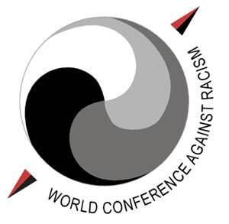
World Conference against Racism, Racial Discrimination, Xenophobia and Related Intolerance

Durban, South Africa
31 August – 7 September 2001 Office of the Spokeswoman


PROCEDURES FOR SCHEDULING PRESS CONFERENCES
United Nations

All press conferences will be scheduled by the Office of the Spokeswoman for the World Conference against Racism.

All requests for press conferences must be made in writing, on official letterhead, and delivered or faxed to the Office of the Spokeswoman for the World Conference against Racism as soon as possible before the requested date.

In the request, please include the name(s) of speaker(s) and subject. This information will be provided to the press. Please be aware that the time slot requested may not be available, in which case an alternative time would have to be arranged. The request should include the telephone and fax number of the person to be contacted to confirm arrangements.

If a delegation wishes to sponsor a press conference, a representative from the delegation must be present to chair it. The United Nations only chairs press conferences given by Heads of State or Government and senior UN officials.

Press conferences must last no longer than one half-hour. Interpretation in English and one other official language will be provided for Heads of State or Government. The delegation must provide an interpreter if a Head of State or Government will speak in a non-official language. TV, audio, photo and press coverage of the press conferences will be arranged by the United Nations Department of Public Information.

Attendance at press conferences is limited to accredited journalists. The only exceptions are the press attaché and other officials of the same delegation directly concerned with the press conference, as well as UN officials covering the press conference.

Press conferences will be held in the Coast of Dreams Hall, next to the Media Centre. The capacity of this room is approximately 100 persons seated.

Press conferences by non-governmental organizations (NGOs) must be sponsored by a UN office/agency or by a Government delegation.

To book a press conference please contact the UN Department of Public Information:
- Prior to 24 August, contact: telephone: 1 (212) 963-1453, fax 1 (212) 963-0536.
- After 24 August, contact the Information Desk in the Media Centre at the Conference. This telephone number will be provided at a later date.

