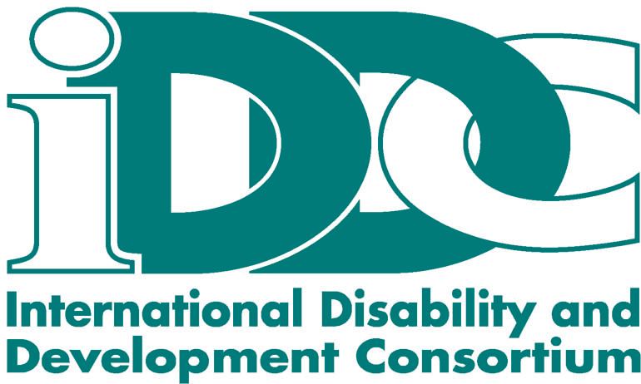

New York, 3 February 2006

Intervention on Article 32 – International Cooperation
As delivered in the plenary of the Seventh Ad Hoc Committee

Thank you, Mr. Chair.

The International Disability & Development Consortium - a global consortium of non-governmental organizations supporting disability and development work in more than 100 countries around the world – fully supports the IDC proposal for a separate Article on International Cooperation.

We express our appreciation to the Ad Hoc Committee for its support of the inclusion of international cooperation as one of the paramount implementation provisions in this Convention and welcome the Facilitator’s efforts in finding suitable and agreeable text.

While we do not want to burden the Ad Hoc Committee with yet another new concept, we believe that inclusive development is the best means to achieve the full enjoyment of all human rights by all people regardless where they live.

Inclusive development ensures that all phases of the development cycle – design, implementation, monitoring and evaluation – are inclusive and ensure meaningful participation of persons with disabilities in all processes and policies.

It also implies a rights-based approach to development, understood as a framework for human development firmly grounded in international human rights standards and focused on the promotion and protection of human rights.

While we understand the stance taken by some delegations that the term “international cooperation” is to be understood as broadly as possible, we underscore the necessity to include persons with disabilities at all levels of development programs. Based on current estimates development programs include only 3-4% of persons with disabilities. Thus, 96% of persons with disabilities do not benefit from development programs. This is not a gap, this is millions of persons with disability not being taken into consideration.

There is a strong trend in many of the national development programs to ensure the inclusion of persons with disabilities in these programs and based thereon support for such a provision should be possible.

As the resolution initiating the current negotiations states – and as was stressed again by High Commissioner Louise Arbour here last week – the present treaty must address both social development as well as human rights. Underscoring this point the High Commissioner stated that “International cooperation must also play a role in ensuring that progress is made everywhere, particularly in less developed States.”

Also, we would like to draw the Committee’s attention to a resolution passed by the Parliament of the European Union last week on the issue of disability & development. We thank the Secretariat for posting it on the ENABLE web site.

The resolution highlights the importance of mainstreaming disability into all levels of international development policy and calls for action on implementing the European Union Guidance Note on Disability & Development.
In addition, the parliament called on the European Commission to support the inclusion of a separate article on international cooperation in the present Convention as – I quote –
“a necessary foundation for collaborative actions in pursuit of inclusive development and to facilitate bilateral and multilateral exchange of expertise, between developing countries and between such countries and the European Union.” End quote.

Finally, looking toward the future, for which this Convention is being created - and in the context of implementation – as well as in light of the ongoing discussions on monitoring we would like to also emphasize the High Commissioner’s statement on the importance of international monitoring for international cooperation.

Thank you.

