The Voice of Self Advocates

Convention for Persons with Disabilities

We are the four self advocates from around the world who are part of Inclusion International’s delegation to the 7th Session of the Ad Hoc Committee.

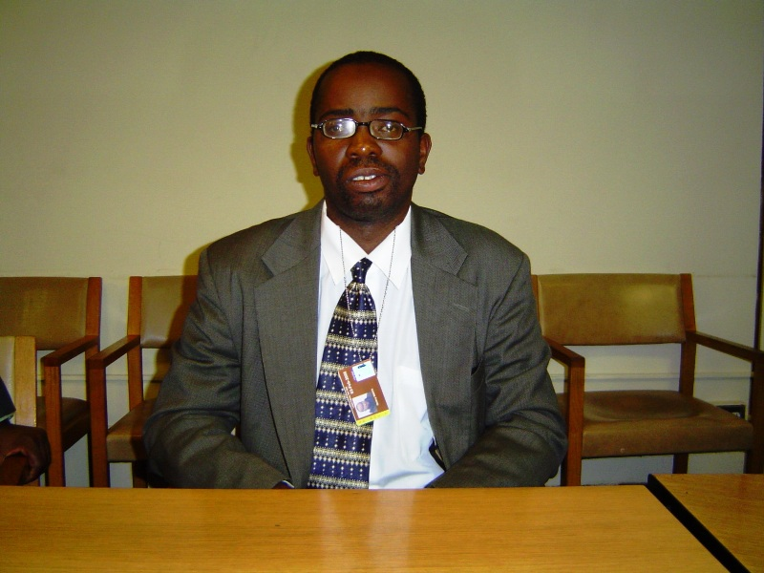

My name is Quincy Mwiya of Zambia. I am 29 years old and speak out for my friends. This is the first time I have come to the United Nations

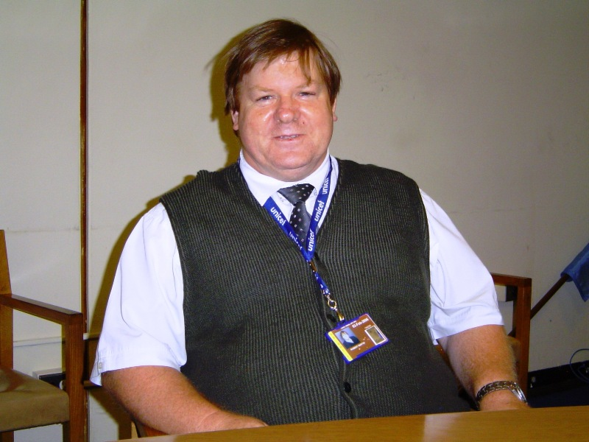

My Name is Robert Martin and I live in New Zealand. I have attended all the sessions of the Ad Hoc Committee.

Labels are for jam jars - not for people
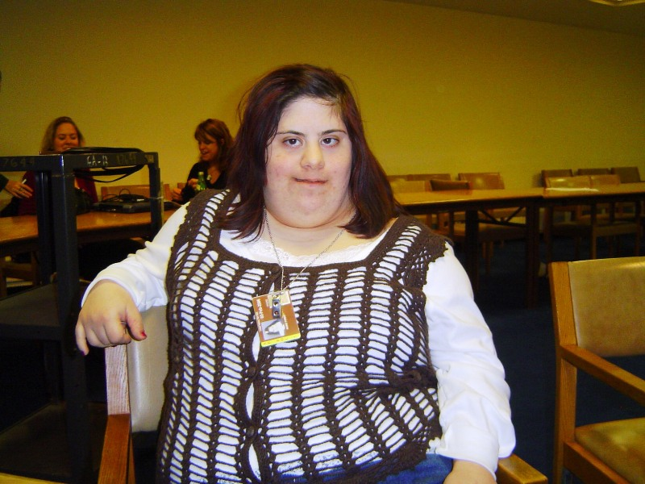
My name is Mia Farah and I come from Lebanon. This is my first time at the United Nations. I believe everyone should be able to go to school together.

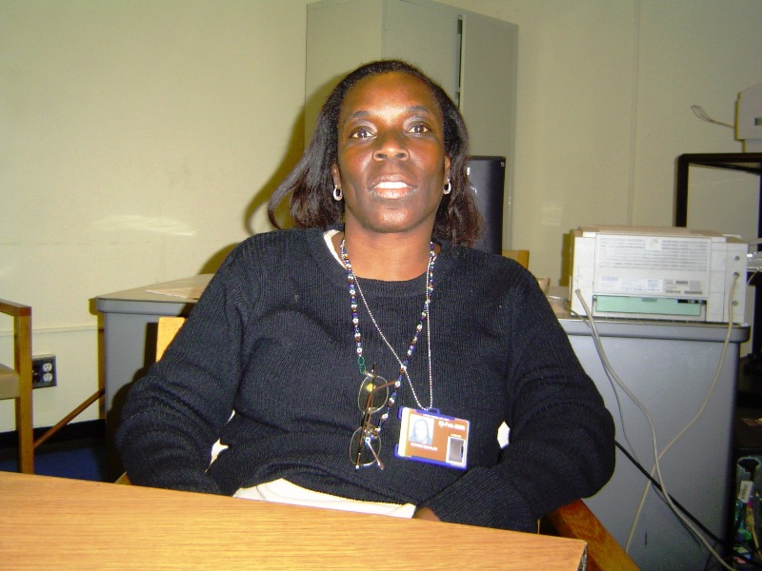

My name is Haydee Beckles and I come from Panama. This is my second visit to the United Nations. I believe that our families are an important part of this Convention.

We Say
- No one must be allowed to control our lives.
- Our families are an important part of who we are.
- We should be able to go to school with the other kids.
- Our poverty also affects our families and our friends.
- Institutions must close; everyone must live in the community.
Our First Week

- Some of us were able to attend the International Disability Caucus Planning Meeting.

- We have taken part in all the International Disability Caucus Meetings. Mia and Quincy explained why our families are so important.

- Robert attended all the International Disability Caucus Steering Group meetings.

- We attended all the Working Sessions of the Ad Hoc Committee. Quincy and Robert made submissions (interventions) at the Sessions.

- We took part in side events during lunch time.

- We ran our own side event “Voice of Self Advocates”

- By Friday night we were very tired. Poor Robert also has to attend a meeting at the weekend.

What is the International Disability Alliance?
Over 60 groups representing disability organisations are members. We try to work together so we can all say the same thing to the Ad Hoc Committee.
Important Stuff

Families must be able to be part of our decision making.

We all need to understand what we mean when we say community.

I need to know that other people care about family as much as I do.

Living in an institution is not a human way of life.

Self advocates from around the world are having a real say.

We all have the right to be make decisions and be included in decisions that affect us.

We need to address poverty. It affects so many people with an intellectual disability, their friends and their family.

People who cannot read do not get the information.

We say

Let’s celebrate togetherness

Let’s celebrate family and friends

Let’s celebrate diversity

Voice of Self Advocates

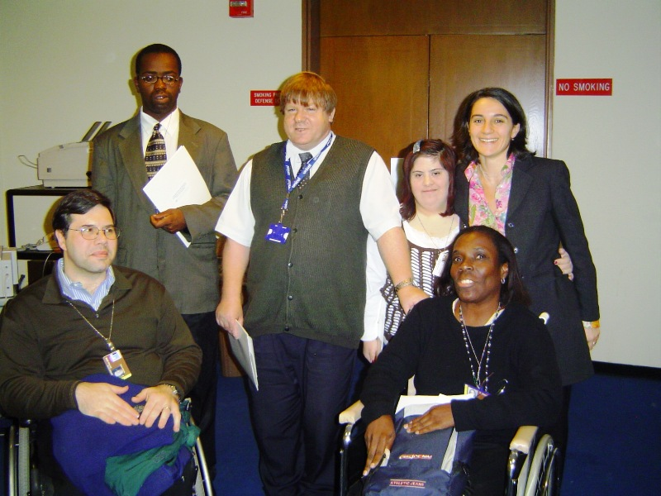

The presenters with Richard Stein (Harvard Law School) and Vittoria Beria (DESA)

We held a side event to help others to understand our issues.

We showed our Video “Linking Local Voices to Global Change”.

We then each gave a presentation on an issue important to us.

The presentations are available on the Inclusion International website.

Richard shared how we could influence others and how important our messages are.

Diane Richler facilitated the meeting and summarised the issues that are important for Inclusion International.

We are grateful for the support of DESA, which is part of the United Nations, for their support in getting us to the Ad Hoc Committee Meeting

Our Messages

Our lives as children

The Convention must ensure that every child has the opportunity to:

Grow up in a family and be loved. This is more than just a right; it is essential part of growing up.

Grow up with friends and know that they belong.

Become a “child of their community” to be valued and wanted for who they are.

Our lives as adults

A successful Convention will ensure that as adults:

We are able to live in the community and be part of community life.

We have control of our own lives and no-one else can make our decisions for us.

We are recognised as the unique human being who we are – others do not try to change us so we fit in.

The things we don’t want

We don’t want anything in the convention that continues the negative labels we have had to live with.

We don’t want anything in the Convention that suggests that we are not capable, lack capacity or any other such nonsense.

We don’t want anything in the Convention that grants control of our lives to others because of the nature of our disability.

