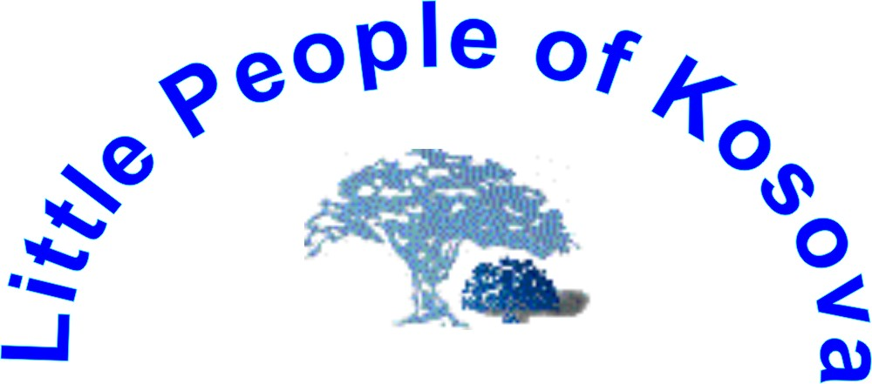

http://www.lpkosovo.tk/

Address: Rr. Adem Trepca No. 4, 40.000 Mitrovice, Kosova – UNMIK,
Tel: ++ 381 (0) 28 24 670; Tel/fax: ++ 381 (0) 28 30 814, Mobile ++ 387 (0) 44 293 518,
++ 381 (0) 63 853 8824

e-mail office: lpkunmik@yahoo.com
Date: | 21st January, 2006 | Ref. No.: 02/2006
For: | Ad Hoc Committee on a Comprehensive and Integral International Convention on the Protection and Promotion of the Rights and Dignity of Persons with Disabilities, Seventh session  New York, 16-27 January 2006, United Nations Global Programme on Disability, 2 United Nations Plaza, Room DC2-137Z New York , NY 10017 USA
From: | NGO Little People of Kosovo
Subject: | Proposal an Article 35: International Campaign Disability Mentoring Day – DMD event

We suggest the following additional Article 35

New proposals are printed in bold letters.

Article 35: -
The International Campaign Disability Mentoring Day – DMD event

States Parties should promote a year-round career exploration program The International Campaign Disability Mentoring Day – DMD in partnership with NGO Organization that help to:
- To promote career exploration and increase employment opportunities for students & job seekers with disabilities through one-on-one job shadowing and group visits to public and private employers.
- Disability Mentoring Day (DMD) is observed on the third Wednesday of October each year.

JUSTIFICATION:

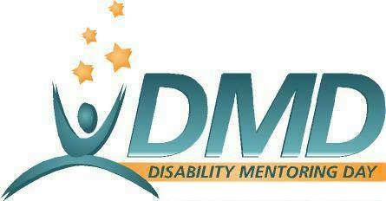

How Did Disability Mentoring Day Get Started?

This program started as National Disability Mentoring Day in 1999 in the White House, as a program to increase the profile of National Disability Employment Awareness Month, which is celebrated every October. The program was patterned after school-to-work activities and began with just three dozen participants. In 2001, National Disability Mentoring Day was passed to AAPD to administer and build; that year, participation included more than 1,500 students and job-seekers, hundreds of public and private employers, and more than 70 Local Coordinators in 32 states plus Washington, D.C. In 2002, National Disability Mentoring Day included the participation of more than 3,800 students and job seekers, hundreds of public and private employers, and 134 Local Coordinators in 41 states and Washington, DC, plus four international locations.

In 2002 marked a dramatic increase in size and scope, marked by involvement of more than 3,500 students and job seekers and over 130 Local Coordinators in 37 states, the District of Columbia, Puerto Rico, the United States Virgin Islands, and first-time international participation in New Zealand and Kosovo (with additional events in Canada and Scotland), involving almost 700 mentoring organizations worldwide.

In 2003 (the year “National” was dropped from the title, because of the considerable international participation), Disability Mentoring Day saw significant growth, with almost 8,000 students and job seekers, 175 Local Coordinators in every state plus Washington, DC, Puerto Rico, the U.S. Virgin Islands and 14 other countries. 2004 had 9,000 mentees participating, 250 Local Coordinators, and more than 2,500 employer mentors.
In 2005 Disability Mentoring Day – DMD event have became International Campaign in about eighteen countries by world: Australia, Bangladesh, Bulgaria, China, Columbia, France, Germany, Ghana, India, Italy, Japan, Kosovo, Mauritania, New Zealand, Nigeria, Pakistan, United Kingdom, United States Of America.
About it you can visit website http://www.dmd-aapd.org/index.php

What Is Disability Mentoring Day?
Disability Mentoring Day – DMD, a year-round career exploration program promotes career development for students and job-seekers with disabilities through job shadowing and hands-on career exploration. With leadership, coordination and resource materials from NGOs’, local communities around the countries and the world organize their own activities that bring students and employers together for informational sessions about career opportunities and one-on-one mentoring with volunteers at public and private places of employment.

What Happens on Disability Mentoring Day?

Disability Mentoring Day – DMD, a year-round career exploration program is officially commemorated on the third Wednesday of every October, but it is then implemented in locations around the country and internationally throughout the year. It is designed to benefit from local creativity, with each community planning activities to best suit the interests and abilities of its students, job-seekers and local employers. Although the core experience is one-on-one job shadowing, event planners may choose to open with a meeting for a group of students and job-seekers featuring several presentations and/or close with a reception where students, job-seekers and mentors can share their experiences. The type of mentoring experience depends in large part on the participants’ interests, education level, and work experience. Job-seekers can focus on specific career advice and discuss potential internships and job openings.

Disability Mentoring Day has the potential to be a powerful community event. Rather than simply encouraging individual employers to reach out to individual schools, for example, States Parties encourages organizers to bring together diverse students and job seekers and connect them with a variety of area employers that best match their interests.

How Can Students and Job-Seekers with Disabilities Benefit from Disability Mentoring Day?

Disability Mentoring Day – DMD, a year-round career exploration program enables students and job-seekers to spend part of a day visiting a business or government agency that matches their interests and have one-on-one time with volunteer mentors. It provides an opportunity to underscore the connection between school and work, evaluate personal goals, target career skills for improvement, explore possible career paths, and develop lasting mentor relationships. History of the program illustrates that students’ and job seekers’ participation in Disability Mentoring Day can result in an internship opportunity with the host employer, function as a first interview on the way to a part-time or full-time employment offer, or even an on-the-spot firm job offer.

How Can Employers Benefit from Disability Mentoring Day?

Disability Mentoring Day – DMD, a year-round career exploration program provides public and private employers with an opportunity to recruit interns, tap a pool of potential future employees, learn more about the experience of disability, develop lasting relationships with disability community leaders, demonstrate positive leadership in their communities and attract positive media attention. Additionally, employers can get involved by enabling employees to serve as volunteer mentors, functioning as a Local Coordinator for a community, and sponsoring Disability Mentoring Day at the national or local level.

How Can Disability Mentoring Day Support Other Programs?

Disability Mentoring Day – DMD, a year-round career exploration program can be a point-of-entry for existing mentoring, school-to-work, internship and employment programs. Since many successful programs around the country require extensive year-round commitments, Disability Mentoring Day can be a way to attract new participants and then encourage them to become more involved a year-round. Employers with summer internship programs can also utilize Disability Mentoring Day as a means to identify promising internship candidates and encourage them to apply

Objectives for DMD

- Career Planning: encouraging persons with disabilities to think early about their careers and develop the skills necessary to compete in the marketplace;

- Empowerment: exposing persons with disabilities to opportunities that can help boost their financial security and inclusion in State’s economic growth;

- Recruitment: providing employers with a pool of talent that can be a hiring source now or in the future; and,

- Workplace Diversity and Inclusion: educating employers about the importance of including persons with disabilities in their diversity initiatives.

Key Players

Workplace Mentors – are volunteers at public and private employers who demonstrate what a job is really like on a day-to-day basis and offer “real world” guidance about what a particular career path entails.

Mentees – are students and job seekers with disability, typically aged 16 ----, who visit employers as an individual for one-on-one job shadowing or as part of a group, based upon their career interests.

Local Coordinators – organize DMD events in towns across the country by mobilizing community participation, recruiting students/job seekers and employers, and planning DMD activities. Local Coordinators are volunteers and can represent a variety of organizations.

Participating Employers -- host Mentees at their worksites, in collaboration with a Local Coordinator.

Employer Coordinators – work independently from a Local Coordinator to organize DMD events at their worksites, by taking the initiative to recruit Mentees and plan all activities.

Educators/Vocational Counselors -- help Local Coordinators and Employer Coordinators recruit students and job seekers and prepare them for participating in DMD.

We wont to summarize briefly about International Campaign DMD in Kosovo 2005;
Disability Mentoring Day – DMD, a year-round career exploration program
Wednesday 19. October 2005
DMD in Kosova is part of international campaign for improving the position of people with disability in the world.
Our Program DMD has been compiled to provide an ‘umbrella’ concept to Voluntary Program of Disability Mentoring Day – DMD that will contribute to the improvement of the current position of disabled people in Kosovo in the areas of humans rights, education, health care, against discrimination and employment possibilities, increase the integration into Kosovo society of people with disabilities and reduce their poverty levels.
The Campaign became even more successful; there have been approximately 1000 mentor-mentee initiatives, including Government, media, private businesses and NGO-s. About 2.000.000 Kosovars have met our poster and message several times by TV, billboards and daily newspaper.
Our activities and Program of DMD Increase awareness and improve Government’s, the public’s and other Kosovo companies opinions relating to people with disability so as to progress their opportunities for education, employment, harvesting the talent of young people with disability, overcome barriers in the minds of people without disability and reduce environmental / infrastructure barriers for the Kosovo community of people with disabilities.
Disability Mentoring Day - DMD was born in USA during 1999 and today many countries follow this event, while the central ceremony of DMD is held at the same time in all over the world every third Wednesday of October.
In Kosovo DMD started to organize in 2002 and now is traditional.
The billboards of DMD were attached in 21 different municipalities Kosova wide during the campaign in 2005.
We printed brochures on three languages ( Albanian, Serbian and English languages) regarding DMD development in Kosovo in past three years.
USA Office Prishtine and Norwegian Embassy donated the DMD Campaign in 2005.
Office of the Prime Minister and Ministry of Health supported the DMD.

CUSTOMS DAY of DMD
Participation in volunteering campaign “ Disability Mentoring Day ” – DMD
UNMIK Customs Service and “Umbrella” Board of DMD organized Customs Day for DMD and singled out a working day for training of people with disability within the framework of DMD Volunteering Campaign and paid a day wage in amount of 10 €, travelling expenses to working places and back home and lunch.
They offered a wonderful chance to get together with kind staff of Customs Service in stations all round Kosovo.
For a day was employed 68 persons with disability and a number of customs officers were engaged in instruction of customs operations, total number of active participants in relation mentor – metees in work was 148 persons.
We wish also other institutions, private sector and public services take into consideration that and follow this good practice of Customs Day for DMD.

About DMD in Kosova you can visit our website http://www.lpkosovo.tk/

