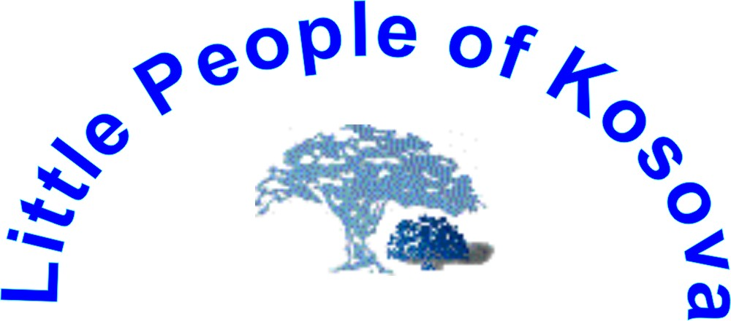

http://www.lpkosovo.tk/

Address: Rr. Adem Trepca No. 4, 40.000 Mitrovice, Kosova – UNMIK,
Tel: ++ 381 (0) 28 24 670; Tel/fax: ++ 381 (0) 28 30 814, Mobile ++ 387 (0) 44 293 518,
++ 381 (0) 63 853 8824

e-mail office: lpkunmik@yahoo.com
Date: | 26st January, 2006 | Ref. No.: 03/2006
For: | Ad Hoc Committee on a Comprehensive and Integral International Convention on the Protection and Promotion of the Rights and Dignity of Persons with Disabilities, Seventh session  New York, 16-27 January 2006, United Nations Global Programme on Disability, 2 United Nations Plaza, Room DC2-137Z New York , NY 10017 USA
From: | Miss. Hiljmnijeta Apuk, NGO Little People of Kosovo
Subject: | Comments on the Chairman's text on Article 6

“Gender equality reform”

Male role in Achievement of Gender Equality

Introduction

Male role as fathers, brothers, school fellows, yokemates, business colleagues, managers, government representatives in local, regional or international levels, certainly is very important and responsible, especially in the advancement of the gender equality. In particular, we have to point out the importance of the equality for the females with psychophysical disabilities

The role of generality of males in their societies consists on being the father, colleague, manager, politician, and/or law and lawful policymaker. The high percentages of them are participating, and have the responsibility, for the current situation of the gender equality, and about the stance of the women with disability.

A controversial issue about the gender equality was widely represented within public programs, and under frame for disposition of women issues, as well as for consolidation of women movement, which operates separately from men participation.

Many male movements exist in the world, and they have quite successful results in accomplishment of the gender equality. Bearers of these kind of movements has to raise their voice, in order to find joint path for the achievement of complete gender equality in each society, and in order to create joint movement aiming gender equality.

Male role in achievement of the gender equality, focused into women and girls with disability

Into life perspective of women and girls with disability, the role of fathers, brothers, cousins and friends is one of the firsts barriers, or better, antecedences which opens the doors of our homes, and enables the participation in the communion, through education, employment, and creation of the conditions for independent life of the persons, and especially for women with especial needs. The male role in advancement of gender equality begins in the family, through modern and perspective parental care for children with especial needs.

Contribution, support and capability of males in achievement of the gender equality, and in involving females with disability in each sphere of life and work

“Gender equality reform” and achievement of specific goals can create joint movement (male-female), and in that manner can contribute in hardening the battle for barrier crossing towards gender equality.

Starting action point for gender equality, and especially focused on women with disability, is the role of fathers and the families.

Males from their position of governing, government and policy making, and in full accordance with women issue, is an excellent position for helping the efforts for the advancement of gender equality, and especially for the approach toward women with disability, in every sphere of their life and work..
Males are truly influencing the governments and parliaments in every country, because they are involved in those system institutions in much higher percentage comparing to women. That way, their capability and capacity to influence men onto course, and to speed up the advancement of gender equality, especially focused on females with especial needs, is very powerful.

Obstacles and challenges for complete communion involvement of females and females with disability

Male resistance linked with gender equality

Male resistance is mainly based onto their stereotyped education caused by the families and tradition, which is derived since their early childhood, as well as from the adolescent hood/bachelorhood period of their life. Through schooling, anyone benefits the system of values, and that way in stereotyped form we glance over, and especially onto women with disability, as at someone who is less valuable person, and that has to be isolated from their families and relatives. Namely, as someone without the rights on education, employment and creation of own values.

Reasons for alteration through male perspective

From the micro point of view – Men reasons for support, in the direction of advancement for position of women in general, and especially for women with disability, has to be done through economical measures; pointing the improvement of well-being of their family life.

Economical interest, from the government, parliament, or other system institutions point of view, has to be based on economical logic, which will lead toward wealth society in general. The employed and educated woman costs state less, and logically, state will spend less means from state funds for diverse recoveries, and at the same time, the equal woman will, in general, contribute for faster state development.

Gender and disabilities – the base of violence

Violence against girls and women with disability is especially expressive, and therefore they are quite often victims of heavy violence into their families or wide surrounding.

Caused by lack of education of women and girls with disability, family based violence, institutional violence, and violence caused by the surrounding of victims, is quite widespread.

Sexual violence is also spread among women and girls with disability.

Fight against all forms of violence is fore shore joint goal of both genders, therefore there’s tendency for joint involvement into this movement.

Models of education for boys and adult men

-Education of boys and adult men has to be reformulated, aiming to get better understanding and development of support between both genders;

-Education of boys and adolescents has to be based on the understanding of the main reasons for all kinds of violence against women and girls, with or without disabilities.

-Information and acknowledgement about the reproductive capacities, and with health protection of women with disability;

-Camping, training, lobbying, representing seminars, workshops, within interactive joint groups of man and women, with or without disabilities, in a way that best promotes joint goals in achievement of gender equality.

Male movement

Male movements have their own history, not only in world dimension, but also in developed and in underdevelopment countries. These movements have shown its high success in lobbying for advancement of gender equality, through diverse campaigns, such is: Campaign against violence on women, campaign against HIV/AIDS, etc.

Alliance with men

There’s quite long period of existence of world female alliance, which addresses its own unequal position to diverse governments, parliaments, institutions, international organizations, etc. But, the alliance operates, without any kind of cooperation with men, toward discovery of common interests and goals, in gender equality in their own surroundings.

Creation of the joint women and men alliance is necessity, because that way there is a possibility for discovering and for the reformation of joint ambition toward the advancement of gender equality as a final mission.

Creation of joint (male-female) lobbying groups, aiming to raise the public conscience about the gender equality, which is everybody’s interest, especially focused onto women with disabilities.

Suggestions for further frame work

Creation of joint forum (males-females), which will continue discussions about gender relations, and that way will better understand the reasons of current situation.

Analyses of the current situation

As starting-point analyses the current situation of women with disability and this very often leads to discrimination, exclusion from the communion, and poverty.
Women, with disabilities
Yesterday
Today
Tomorrow

Women with disability

Yesterday

Women yesterday under pressure of:

1. Tradition
2. Patriarchal relations
3. Violence
4. High level of mortality
5. Lack of education
6. Little and symbolic participation in social courses
7. Insufficient information
8. Poverty

Today
Women with disability

Today by rights and necessarily need to influence in increase of conscience, creation, and development of:

- Education
- Health care
- Human rights
- Politics -
  - Law
  - Economy (eradication of poverty, employment, micro credits, etc)
  - Social welfare, especially for people with disability, and their family members
  - Organizing of outhouse services
  - Standards and their implementation, especially world standards for persons with special needs
  - Integrations in all fields
  - Creation of new models of assistance services, and their successful use in education, health, social welfare, primarily for the persons with especial needs, and linked with life improvement
  - Planning of general society development
  - International cooperation
- Clearance and information
  - Personal trainings
  - Importance of medias in clearance of public relations toward persons with especial needs
- Strategy
  - Development of institutional cooperation in national and International level
  - Development of representation toward government, and within government
- Development of unified goals with male movement in all life spheres

Tomorrow

Women with disability

Workingwomen
Successful
Independent
Health insured
Educated
Informed
Economically independent
Happy in family and society

