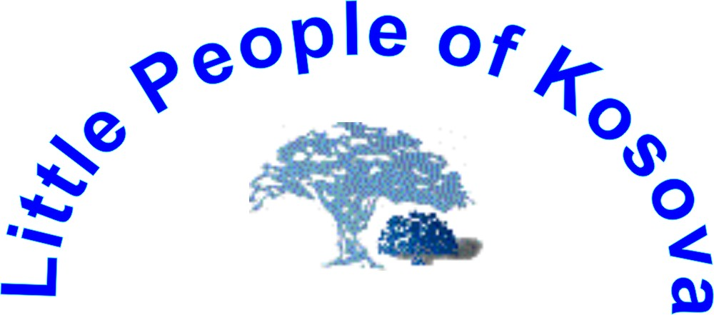

http://www.lpkosovo.tk/

Address: Rr. Adem Trepca No. 4, 40.000 Mitrovice, Kosova – UNMIK,
Tel: ++ 381 (0) 28 24 670; Tel/fax: ++ 381 (0) 28 30 814, Mobile ++ 387 (0) 44 293 518,
++ 381 (0) 63 853 8824
e-mail office: lpkunmik@yahoo.com

Date: | 20th January, 2006 | Ref. No.: 01/2006
For: | Ad Hoc Committee on a Comprehensive and Integral International Convention on the Protection and Promotion of the Rights and  Dignity of Persons with Disabilities, Seventh session New York, 16-27 January 2006, United Nations Global Programme on Disability,  2 United Nations Plaza, Room DC2-137Z, New York  NY 10017 USA
From: | Miss. Hiljmnijeta Apuk. President and Main Editor in chief office of monthly publication of disabled persons of Kosova
Subject: | Comments on the Article 8 of the UN Convention on the Protection and Promotion of the Rights and Dignity of Persons with Disabilities, Seventh session

Dear friends,

Allow us to introduce by our website http://www.lpkosovo.tk/

Introduce:

The activities of our NGO broadly conform to purposes of the Ad Hoc Committee and about us you can visit our website on address http://www.lpkosovo.tk/

For each campaign in which we are involved we develop Promotional Voluntary Packages Program of Disability Mentoring Day – DMD to raise awareness throughout society regarding disability and persons with disabilities, and to foster respect for their rights. We developed a pack for Disability Mentoring Day - DMD that promoted human rights, freedom and positive images and the need for employment opportunities for people with disabilities. We are also active to introduce the issue of disability in to other debates on social matters in an attempt to mainstream the issue of disability and to promote social inclusion. On Valentine's Day we led with a programme and promotional package, which focussed on the emotional and romantic, lives of people with disabilities; we too experience the same emotions as people less challenged. On International Women’s Day, 8th March we focussed on women living with a disability and on International Day of the Child, 1st of July, we highlighted the lives and needs of children living with a disability. Our over arching intention is to promote the issues of disability all year-round and to synchronise our work with other social issues to mainstream discussions on disability within the new and emerging society of Kosovo.

Non-profit monthly publications

Newspaper Persons with Disability of Kosovo”

March 2003 – currently
Non profit unique monthly magazine “ Newspaper People with Disability of Kosova” as attachment in daily newspapers on two official languages: Albanian and Serbian/ Bosnian language.
The main conclusion of this Newspaper PWDK was to establish an observatory on the status and rights of disabled people in Kosovo and create national policy toward improvement position of disabled people. We people with disability should be equally valued by society regardless of our differences or of the roles we play.
About 600.000 readers (citizens of Kosovo) readied the Newspaper PWDK in past 20 months.
- Initiating and maintaining public awareness campaigns designed to nurture an effective receptiveness to the rights of persons with disabilities;
- Encouraging all sections of society to develop and maintain as appropriate, disability-sensitive awareness employment programs for disabled people.
- Raise awareness throughout society regarding disability and persons with disabilities and to foster respect for their rights.

Miss. Hiljmnijeta Apuk is woman with disability and the Main Editor in chief office of the Newspaper Persons with Disability of Kosova.

In partnership with the Provisional Institutions of Government of Kosovo and UNMIK we would like to stimulate debate and to promote positive public opinion towards the Convention on the Rights of Persons with Disabilities.

We suggest the following additions to Article 8

New proposals are printed in bold letters.
Article 8: Raising awareness regarding disability
1. States Parties undertake to adopt immediate and effective measures:
(a) To raise awareness throughout society regarding disability and persons with disabilities, and to foster respect for their rights by promote packet program of campaigns that is a year-round efforts;
(b) To combat stereotypes and prejudices about persons with disabilities in all areas of life;
(c) To promote awareness of the capabilities and contributions of persons with disabilities.
2. Measures to this end include:
(a) Initiating and maintaining effective public awareness campaigns designed:
(i) To nurture receptiveness to the rights of persons with disabilities;
(ii) To change negative perceptions and social prejudices towards persons with disabilities in all matters of [sexuality,] marriage, parenthood and family relations of persons with disabilities;
(iii) To promote recognition of the skills, merits, abilities and contributions of persons with disabilities to the workplace and the labour market;
(b) Fostering at all levels of the education system, including in all children from an early age, an attitude of respect for the rights of persons with disabilities;
(c) Encouraging persons with disability to be makers of own media that would be included as attachments in media and all organs of the media to portray persons with disabilities in a manner consistent with the purpose of the present Convention; -
(d) Promoting disability-sensitive awareness training programmes.

Justification:

We have gained experiences from developing a Promotion Voluntary Packet Program of Disability Mentoring Day (DMD), that includes campaigns regarding next goals and objectives: human rights to dignity of persons with disability (Valentines’ Day with focus on disabled people), women with disability (International Women Day 8th March with focus on women with disability), children with disability (International Children Day 1st June with focus on focus of disabled children) employment opportunities for persons with disability, inclusion in society and employment rights (third Wednesday in October – Main celebration of Disability Mentoring Day (DMD)) through which we were able to promote our human rights, freedom and abilities. Thus, the Promotion Packet Program of Campaigns is a year-round effort, which contains recognized International Campaigns with focus on persons with disability.
This Promotion Packet Program of Campaigns with focus on persons with disability should be a partnership with State, be responsive to public opinion for the purpose of promoting our goals and objectives contained in the Convention on the Rights of Persons with Disabilities.
Regarding Disability Mentoring Day – DMD you can visit
Website: http://www.dmd-aapd.org/

Persons with disability should be active makers of own media that will be included as attachments in all kind of media. Persons with disability would be encouraged to promote purpose of the present Convention together with other media makers.

Exemplar:
Calendar is one of year-round efforts from the Promotion Packet Program of Campaigns, which contains recognized the purpose of the present Convention. We were able to make it by skills of disabled persons. It was advertised and delivered by our Newspaper Persons with Disability of Kosova as attachment in others daily newspapers.

